Submission Date

15/1/2017

Assignment 1: Web Development

URL: <https://ashleighf1996.github.io/csy1018-assign1/index.html>

University Of Northampton

16427265

Ashleigh Claire Foster

**Intro**

In this documentation, I am going to be talking about the development of my simple CV portfolio website all the way from the first initial stages of the design to the final implementations of the website.

**Research**

The main purpose of conducting a research analysis for each of my webpages was to gather and collect some ideas on how I would go about designing my overall CV portfolio website. There were a few websites which I have used to gather these ideas and inspirations from including:

<https://joel.sh/>

* Circular imagery
* Header
* Navigation line
* Logo design

<http://www.wix.com/website-template/view/html/1676?originUrl=http%3A%2F%2Fwww.wix.com%2Fwebsite%2Ftemplates%2Fhtml%2Fportfolio-cv%2Fresumes-cvs%2F1&bookName=&galleryDocIndex=8&category=portfolio-cv>

* Home page design
* Colour Scheme
* CV line breaks

**Sketches**

[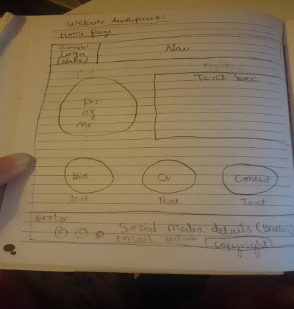](https://cloud.githubusercontent.com/assets/22633852/21942587/98f294da-d9c5-11e6-8488-d3525cc21d1f.jpg)**Home Page**

[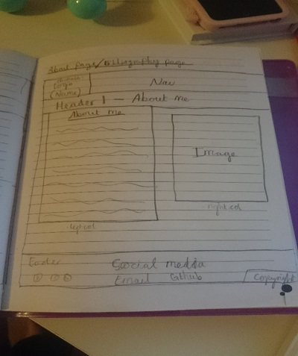](https://cloud.githubusercontent.com/assets/22633852/21942722/11dceb70-d9c6-11e6-9bd3-dc1b65c1c60c.jpg)**About**

**CV**

[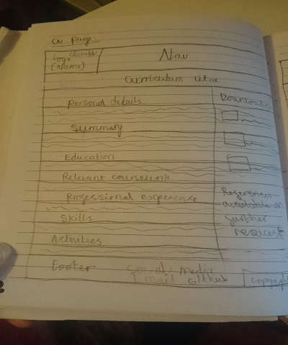](https://cloud.githubusercontent.com/assets/22633852/21942815/6769da4e-d9c6-11e6-8342-409575a1c30d.jpg)

[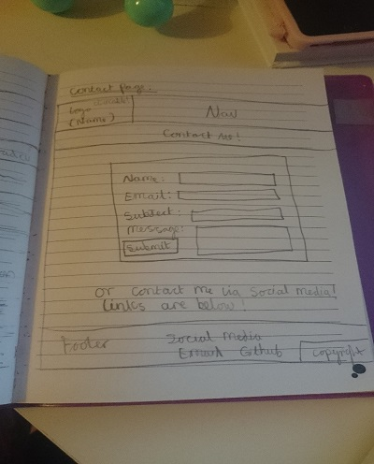](https://cloud.githubusercontent.com/assets/22633852/21942846/8e474d2c-d9c6-11e6-9bc2-28abd69c87bc.jpg)**Contact**

**Colour Scheme**

[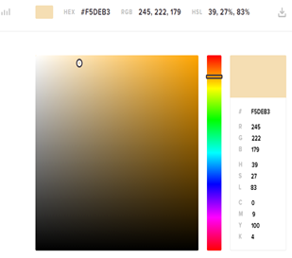](https://cloud.githubusercontent.com/assets/22633852/21942982/27c8ec8a-d9c7-11e6-92b5-defddea2089d.png)[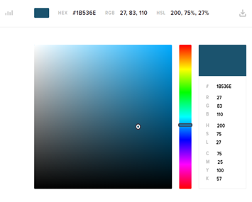](https://cloud.githubusercontent.com/assets/22633852/21942975/1ec50ce0-d9c7-11e6-83c2-8f76d14198c9.png)[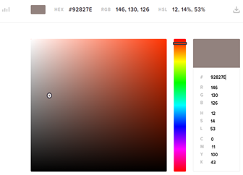](https://cloud.githubusercontent.com/assets/22633852/21942959/146a4c56-d9c7-11e6-8881-cb74e335bfbd.png)[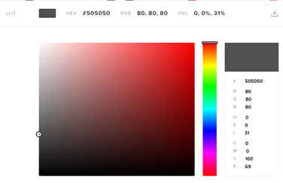](https://cloud.githubusercontent.com/assets/22633852/21942946/059aaefa-d9c7-11e6-9c11-f82c5c445447.png)For the background colour, I used the same background colour as was used on the Wix website. For the rest of the website I decided to think about not only a more professional view but one that will make my CV website suit colour blind users. I decided to incorporate a black, grey, white & blue every now and then.

**Wireframes**

[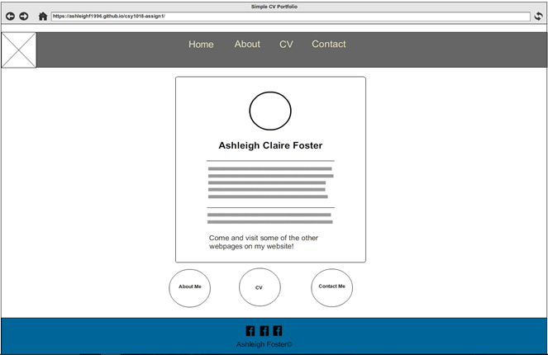](https://cloud.githubusercontent.com/assets/22633852/21943043/6de87550-d9c7-11e6-93d2-7c858557ab48.png)**Home Page**

[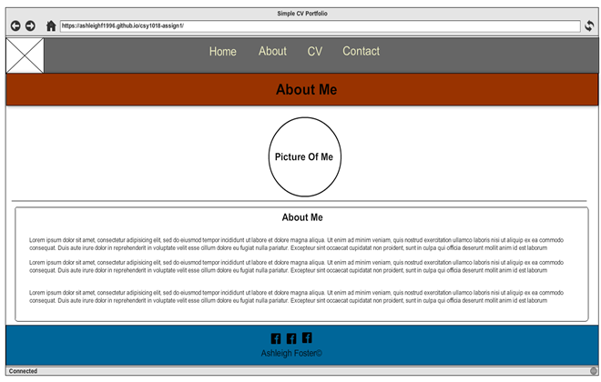](https://cloud.githubusercontent.com/assets/22633852/21943061/8fde0242-d9c7-11e6-86a2-9315281d0f02.png)**About**

**CV**

[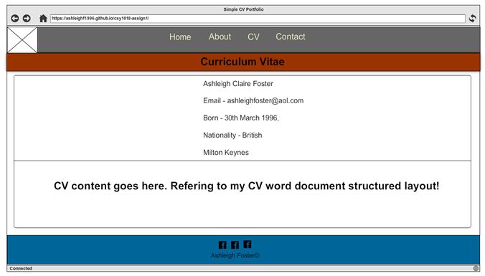](https://cloud.githubusercontent.com/assets/22633852/21943075/9cbfab28-d9c7-11e6-8afb-2779c0b0c40c.png)

**Contact**[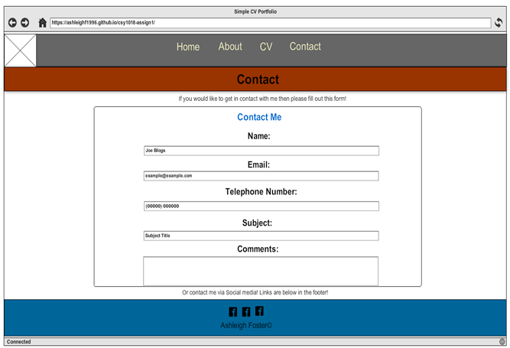](https://cloud.githubusercontent.com/assets/22633852/21943186/fa089434-d9c7-11e6-8cdc-1fad2128985e.png)

**Navigation Diagram**

[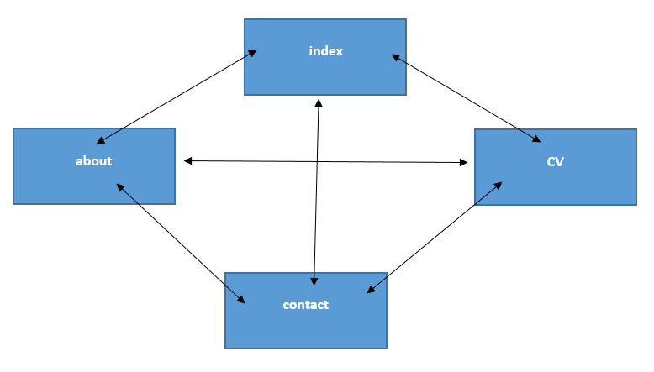](https://cloud.githubusercontent.com/assets/22633852/21943272/6ba61cec-d9c8-11e6-8dec-5b83d8c3ac74.png)

**Logo**

I decided to choose the first design because I thought that it would look simpler and more professional plus it is a type of logo which is commonly used in CV websites or portfolio website i.e. having the letters merged together. I then went ahead and took the colour scheme of my website into consideration and then started to design the logo in Adobe Photoshop. The types of effects I used when designing the overall layout of the logo were “Bevel & Emboss” and “Gradient overlay”. The font size which was used was 72 pt. and the font style is “Imprint MT shadow”.

[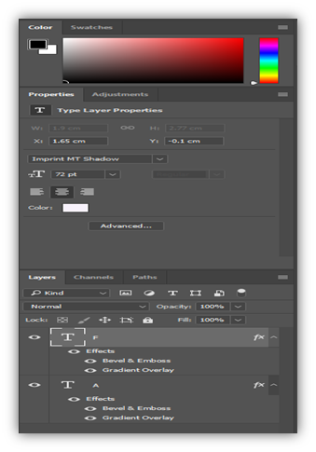](https://cloud.githubusercontent.com/assets/22633852/21943483/524ee52a-d9c9-11e6-814a-570bdcc963a3.png)[](https://cloud.githubusercontent.com/assets/22633852/21943458/3850f35c-d9c9-11e6-9c8e-6862e05da771.png)[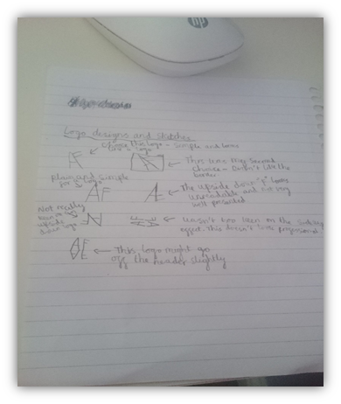](https://cloud.githubusercontent.com/assets/22633852/21943398/fdfc3c0c-d9c8-11e6-80dc-f2ad4f362646.png)

**Google Fonts**

* Indie Flower
* Lobster
* Raleway
* Roboto
* Rokkitt

**Progression of website**

[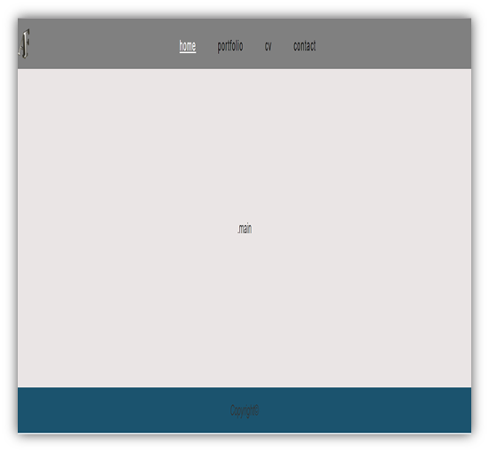](https://cloud.githubusercontent.com/assets/22633852/21946253/78eeaf18-d9d7-11e6-9cde-76da7b508eee.png)**1st Version**

**2nd Version**

[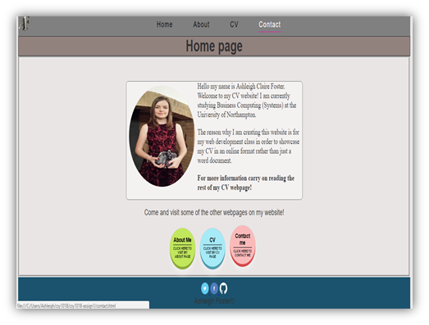](https://cloud.githubusercontent.com/assets/22633852/21946276/99ec1f3e-d9d7-11e6-8712-9c65dfd4f684.png)

[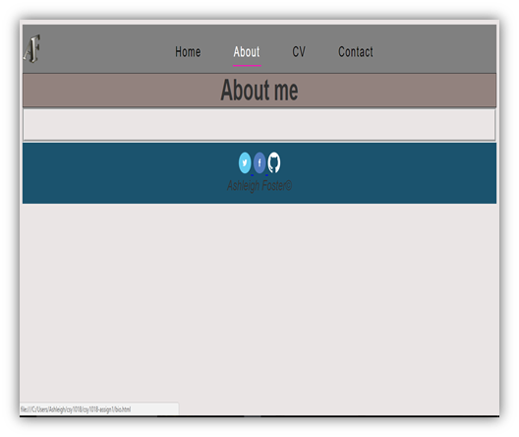](https://cloud.githubusercontent.com/assets/22633852/21946301/b82ce852-d9d7-11e6-9525-94647b70938b.png)

[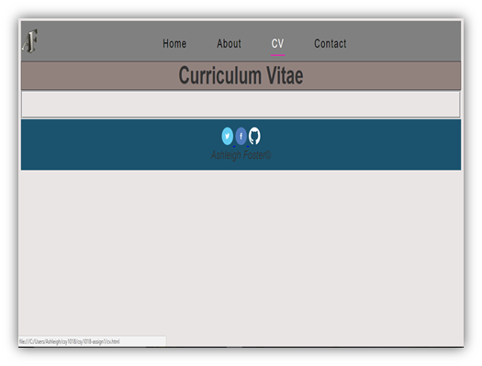](https://cloud.githubusercontent.com/assets/22633852/21946321/c6e3265e-d9d7-11e6-8ceb-3b2fb3f755ce.png)

[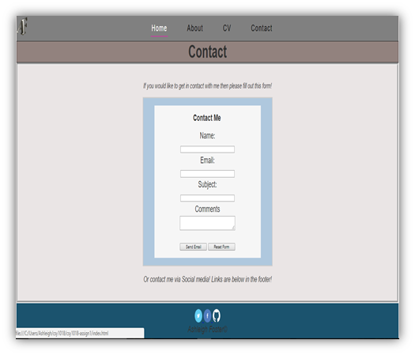](https://cloud.githubusercontent.com/assets/22633852/21946364/079b087e-d9d8-11e6-8612-40d6c0681fee.png)

[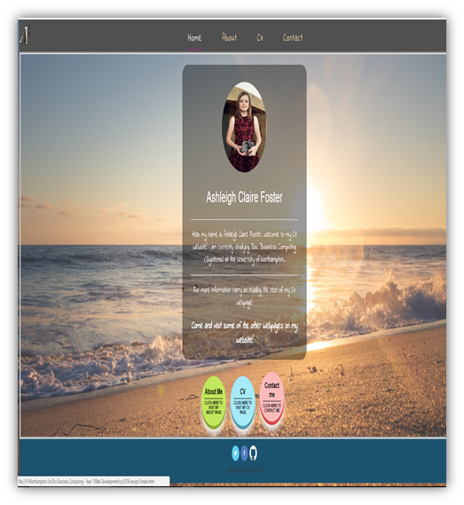](https://cloud.githubusercontent.com/assets/22633852/21946393/3145a8f0-d9d8-11e6-9985-33879b00d1c5.png)**3rd Version**

[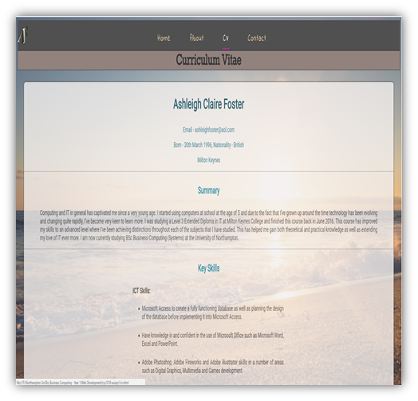](https://cloud.githubusercontent.com/assets/22633852/21946429/5f69c4c8-d9d8-11e6-8b7f-f63e3922501e.png)[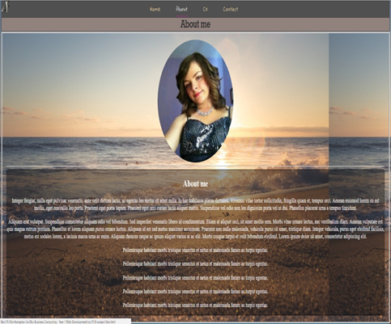](https://cloud.githubusercontent.com/assets/22633852/21946415/50243c50-d9d8-11e6-981d-aef3c52e1181.png)

[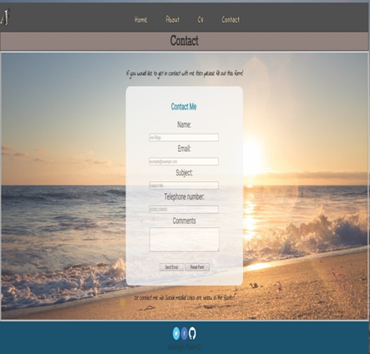](https://cloud.githubusercontent.com/assets/22633852/21946446/7593061a-d9d8-11e6-9d2e-af3790306f41.png)

[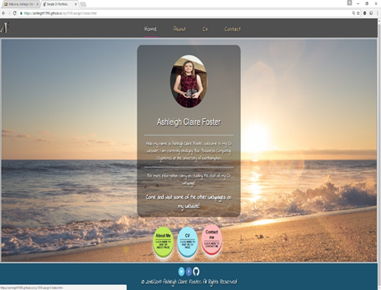](https://cloud.githubusercontent.com/assets/22633852/21946485/9c860ccc-d9d8-11e6-8e6e-6fd6ddf48624.png)**4th Version**

[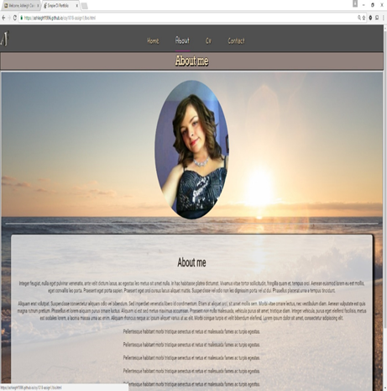](https://cloud.githubusercontent.com/assets/22633852/21946509/adf41a80-d9d8-11e6-8195-a667e475da03.png)

[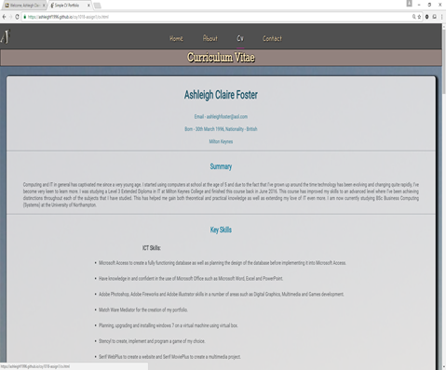](https://cloud.githubusercontent.com/assets/22633852/21946532/bde95464-d9d8-11e6-8a83-9ee78919404c.png)

[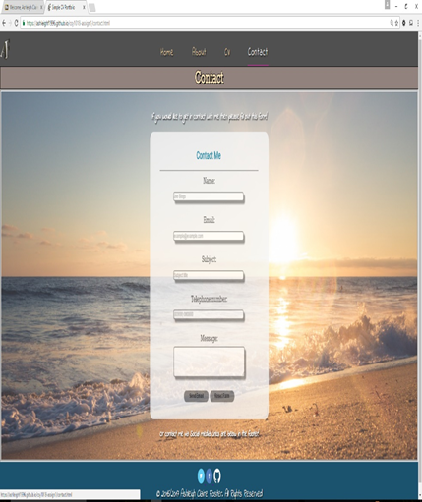](https://cloud.githubusercontent.com/assets/22633852/21946547/cd05e6a6-d9d8-11e6-8d56-0451bae9e841.png)

[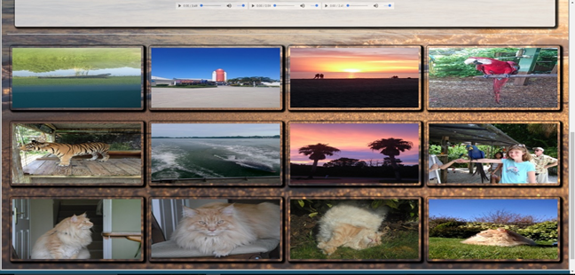](https://cloud.githubusercontent.com/assets/22633852/21946584/f714b120-d9d8-11e6-831f-e57d0e71d555.png)[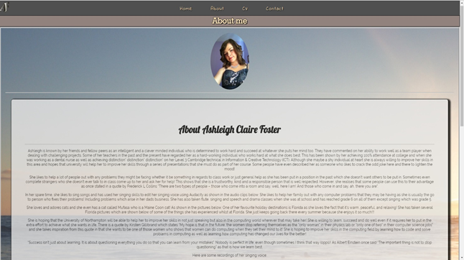](https://cloud.githubusercontent.com/assets/22633852/21946575/ea4f15ca-d9d8-11e6-9b77-53825b5ae5df.png)**Final Version**

**Validation (HTML & CSS)**

[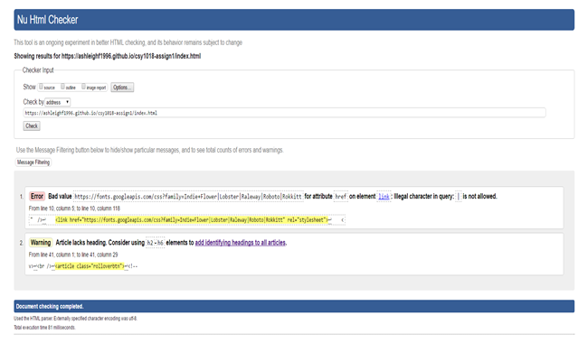](https://cloud.githubusercontent.com/assets/22633852/21947134/80d0e94a-d9db-11e6-9af0-9c113788a39f.png)**Index**

I have tried fixing the errors on the index.html webpage but sadly when I was trying to fix these errors there were more errors popping up in the code. In the end, I decided to leave it be as it was unfixable.

**About**

[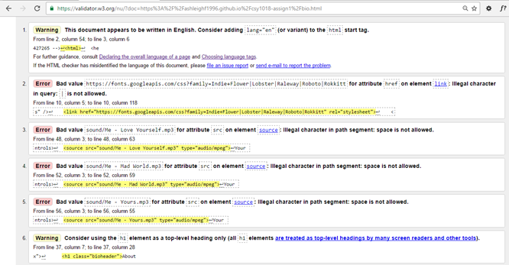](https://cloud.githubusercontent.com/assets/22633852/21947336/8f5697c0-d9dc-11e6-9fca-b60c8b49382f.png)

I have managed to fix the sound code errors as I accidently left spaces in-between each of the file names which is totally unprofessional. I have managed to fix the language error by changing it to English in the HTML code. I have managed to fix the header error by changing the heading1 font to heading2.

[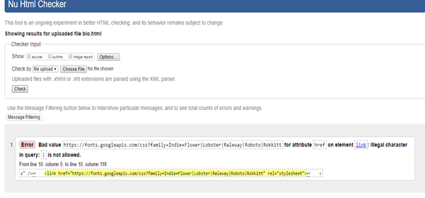](https://cloud.githubusercontent.com/assets/22633852/21947487/5b279548-d9dd-11e6-908a-63e41de4caef.png)

**CV**

[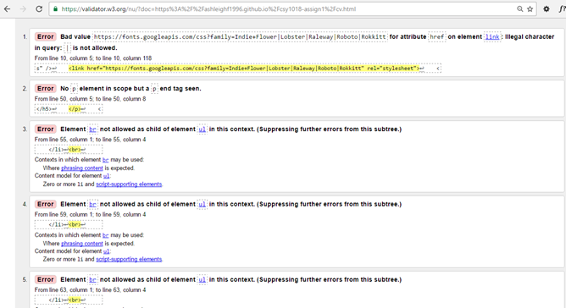](https://cloud.githubusercontent.com/assets/22633852/21947497/6aacfdb4-d9dd-11e6-810f-91d30740e90d.png)

[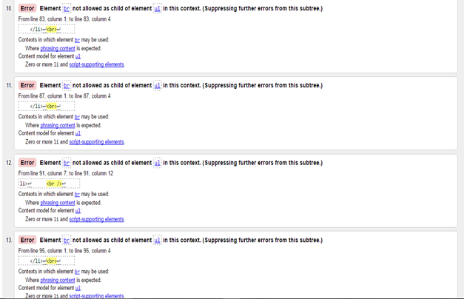](https://cloud.githubusercontent.com/assets/22633852/21947520/8aa13cf2-d9dd-11e6-861b-8ddb023a39b0.png)[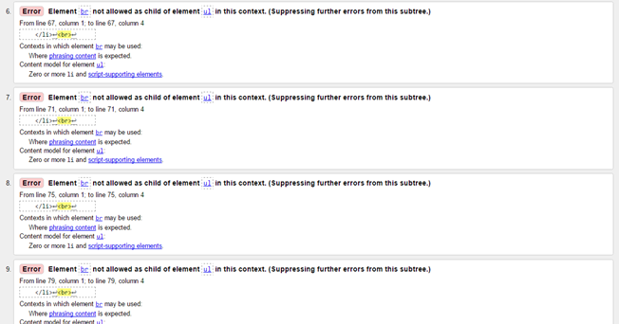](https://cloud.githubusercontent.com/assets/22633852/21947512/7f92517a-d9dd-11e6-8fba-505d792f9704.png)

[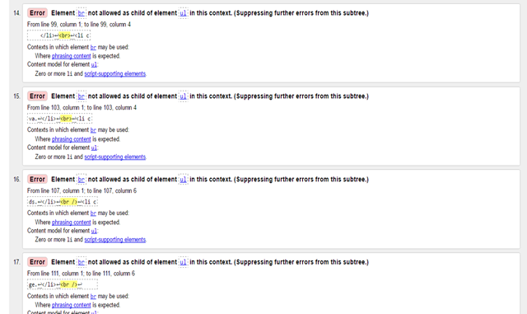](https://cloud.githubusercontent.com/assets/22633852/21947524/93b5e554-d9dd-11e6-885e-791eda45a783.png)

**[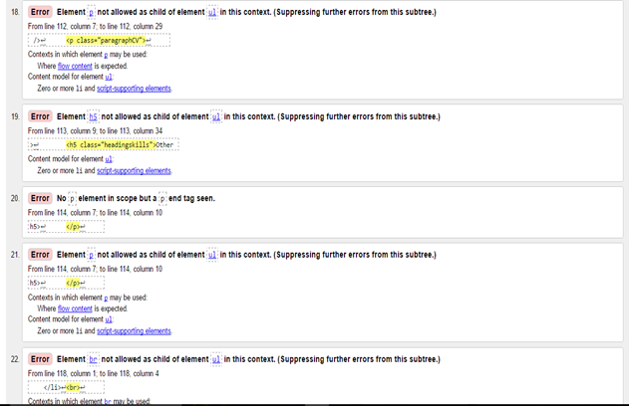](https://cloud.githubusercontent.com/assets/22633852/21947534/a0548e1e-d9dd-11e6-99f9-27e72b01a3c7.png)**

[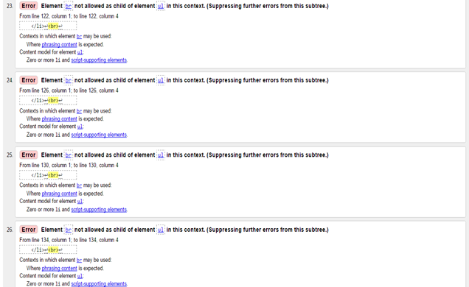](https://cloud.githubusercontent.com/assets/22633852/21947544/b184e71a-d9dd-11e6-8509-7f217cac3924.png)

[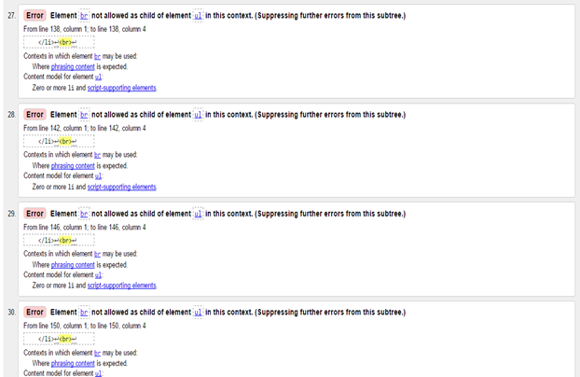](https://cloud.githubusercontent.com/assets/22633852/21947548/bca86e96-d9dd-11e6-941e-458e31b4f6b5.png)

[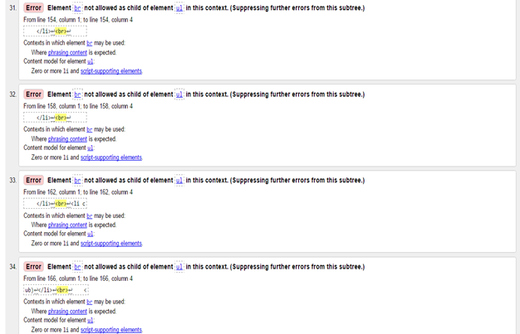](https://cloud.githubusercontent.com/assets/22633852/21947557/c68c61ec-d9dd-11e6-8426-eabb67ab6905.png)

[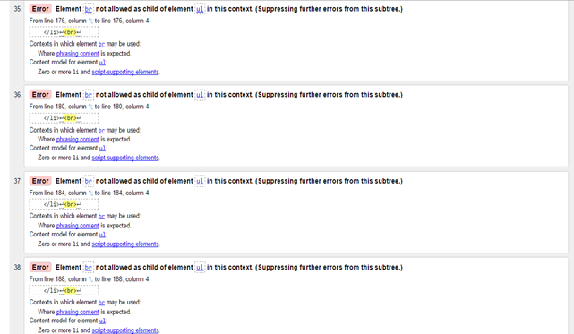](https://cloud.githubusercontent.com/assets/22633852/21947564/d1241f6e-d9dd-11e6-99ab-226464243995.png)

[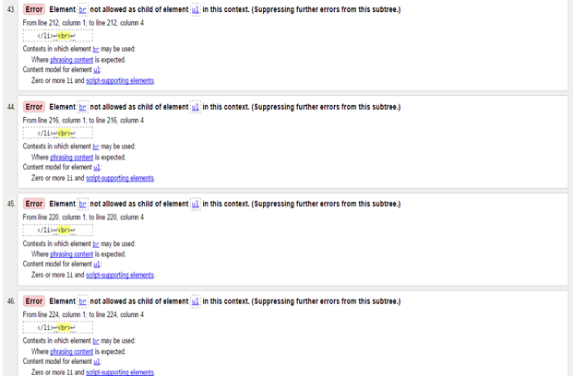](https://cloud.githubusercontent.com/assets/22633852/21947591/e3ed13c6-d9dd-11e6-9144-a4ed3f7dbeb0.png)[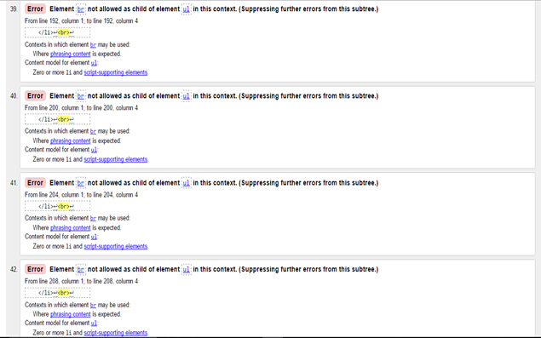](https://cloud.githubusercontent.com/assets/22633852/21947577/da23d58c-d9dd-11e6-85cf-99e71ed2f425.png)

[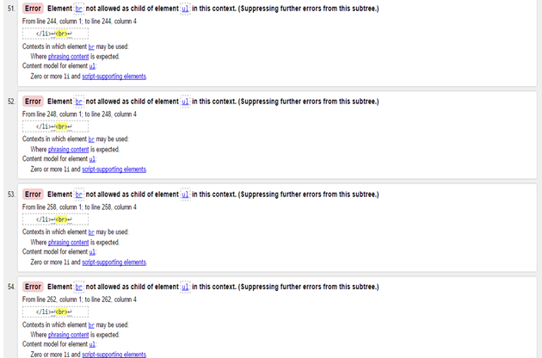](https://cloud.githubusercontent.com/assets/22633852/21947609/f7322192-d9dd-11e6-891c-655bdff7a5d3.png)[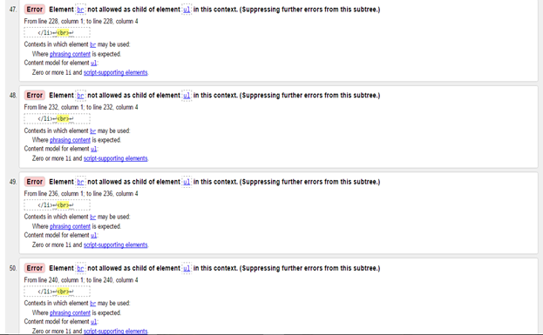](https://cloud.githubusercontent.com/assets/22633852/21947599/ed6b404e-d9dd-11e6-927e-536fbed56a57.png)

[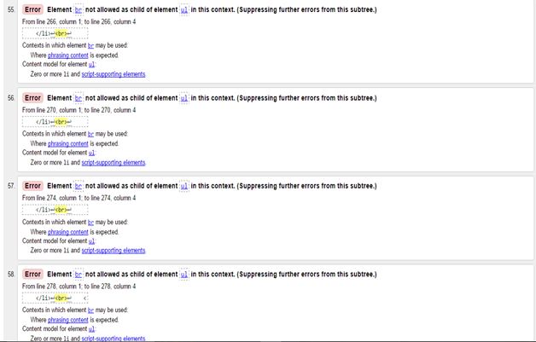](https://cloud.githubusercontent.com/assets/22633852/21947620/02681364-d9de-11e6-893e-b3c556e74077.png)

[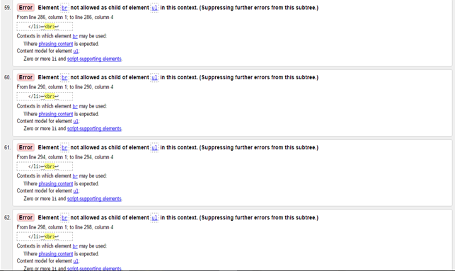](https://cloud.githubusercontent.com/assets/22633852/21947629/0d6bb93c-d9de-11e6-8127-2a603ae5c611.png)

[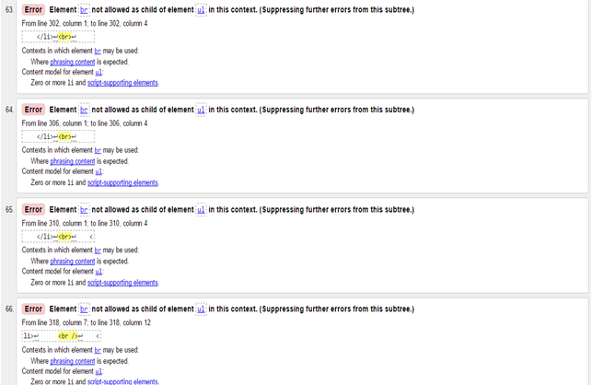](https://cloud.githubusercontent.com/assets/22633852/21947645/1ac990cc-d9de-11e6-8d1a-8a395d6a14e8.png)

[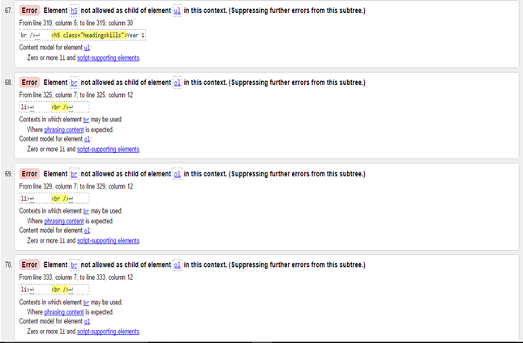](https://cloud.githubusercontent.com/assets/22633852/21947657/23d1957a-d9de-11e6-9452-7d337e9d570f.png)

[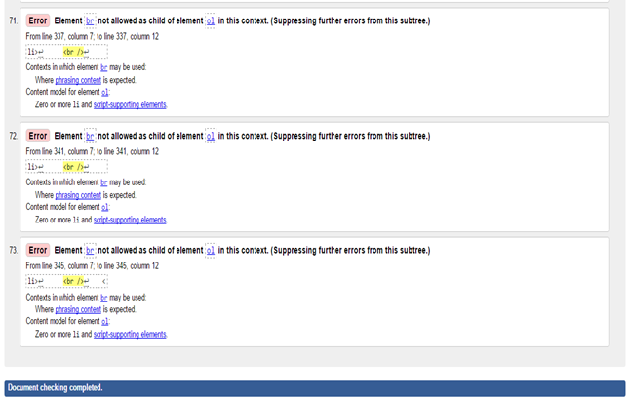](https://cloud.githubusercontent.com/assets/22633852/21947662/2cc68a8c-d9de-11e6-8665-889aada07438.png)I have managed to fix all the BR errors that were occurring most frequently as an error in the validator. This was fixed by adding paragraphs inside each of the list items. I have gotten rid of the paragraph and header errors by getting rid of the singular paragraph tag that was accidently added in there and making sure that I have structured the headers properly.

[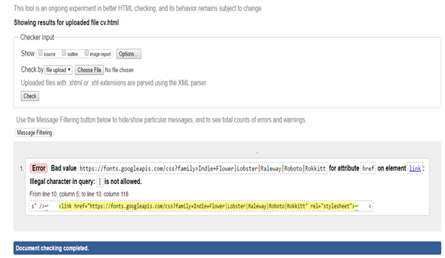](https://cloud.githubusercontent.com/assets/22633852/21947781/e32f1550-d9de-11e6-99ee-69650c4bf76a.png)

[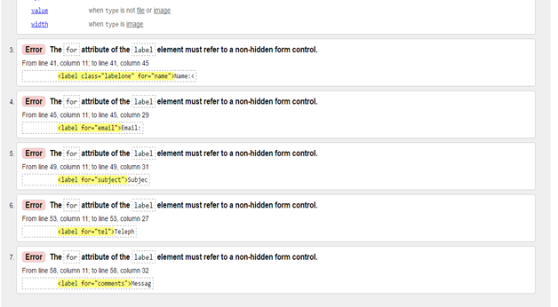](https://cloud.githubusercontent.com/assets/22633852/21947826/1f447440-d9df-11e6-987a-91f3aa576fc8.png)**Contact**

[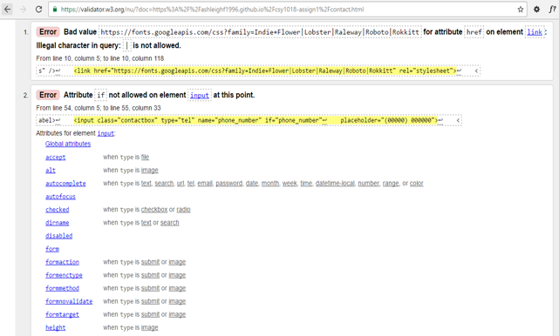](https://cloud.githubusercontent.com/assets/22633852/21947810/0dc2151a-d9df-11e6-8d1a-e77934a497e0.png)

I have managed to fix all the 7 error codes that were causing and or showing up on the W3C validator. Much of the codes stated that I needed to fix the following code “The for attribute of the label element refer to a non-hidden form control.” To fix this error code I had to look up this code on Google and came across a stack overflow website whereby someone had the same problem previously as me and there were others who had already solved this problem. I then looked at the code and recognised that I needed to put “ID’s” in the code so that the HTML elements on my contact page weren’t causing that same error and for the telephone number I had also made the mistake of not having the same “tel” name throughout my telephone input code which was why it was causing problems. The stack overflow website will be referenced in the reference section at the bottom of my report. For the “Attribute if not allowed on element input at this point” error message code I have managed to fix this error that showed up in the W3C validator by getting rid of the IF statement completely as it wasn’t necessary to put that element there and it didn’t cause any problems once I got rid of it either.

[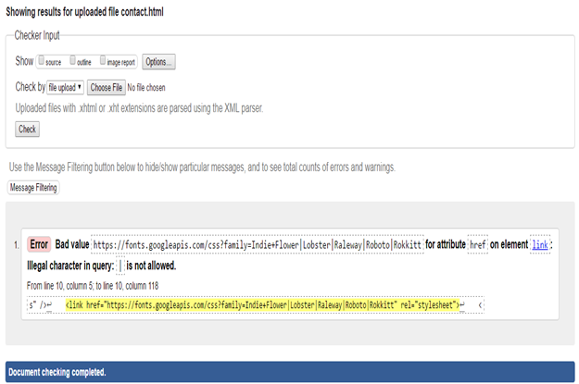](https://cloud.githubusercontent.com/assets/22633852/21947942/d176df4a-d9df-11e6-85b6-8a305fb41615.png)

**CSS validator**

[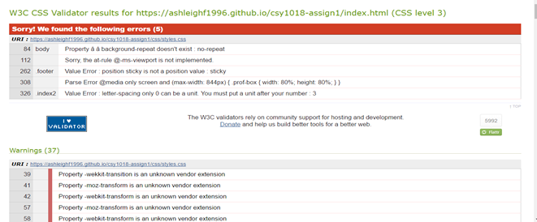](https://cloud.githubusercontent.com/assets/22633852/21947977/122a4838-d9e0-11e6-8702-e94dff45eb66.png)

[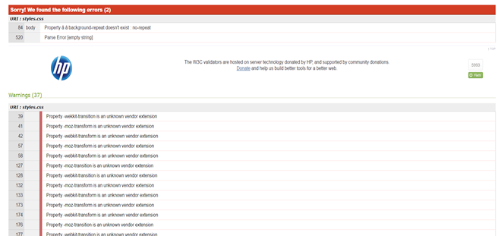](https://cloud.githubusercontent.com/assets/22633852/21947987/21d8699a-d9e0-11e6-8998-fc31c62ffc32.png)

I have managed to validate 4 known errors; however, I couldn’t validate at least 2 errors and the rest of the 37 warnings which are below the main errors. The 3 errors which I did fix which were “sorry, the at-rule @ -ms-viewport is not implemented”, “Value Error: Position sticky is not a position value: sticky”, “Parse Error @media only screen and (max-width: 844px)” and “Value error: letter-spacing only 0 can be a unit etc…” where all fixed by either commenting out that piece of CSS code or getting rid of the CSS completely which managed to fix the error plus adding some additional CSS after getting rid of the ms-viewport error which changed my “about me” picture. For the first error, I couldn’t fix the “property background-repeat doesn’t exist: no-repeat” error because when I changed it my background started to repeat itself again. This code does exist as it has been published on a variety of different websites so it could be the validators problem. The other error which popped up was “Parse error [empty string]” Again this was a known validator problem and not something I could personally change in the CSS as I Googled the error and other people had this problem with the CSS validator.

**Work Log**

**Total Hours Spent: 136 hours and 10 minutes**

[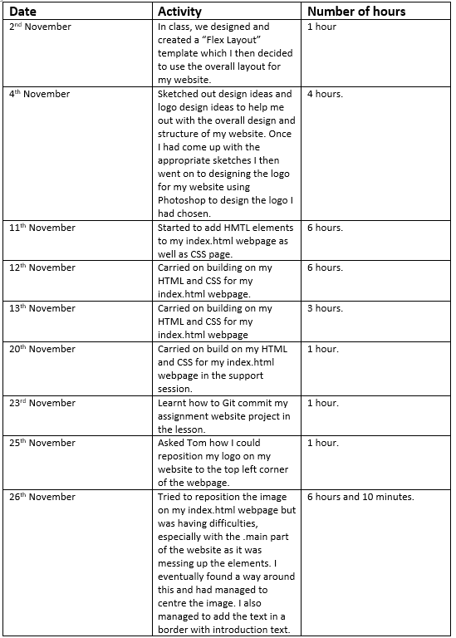](https://cloud.githubusercontent.com/assets/22633852/21948206/81e6856e-d9e1-11e6-8339-70fce8750161.png)

[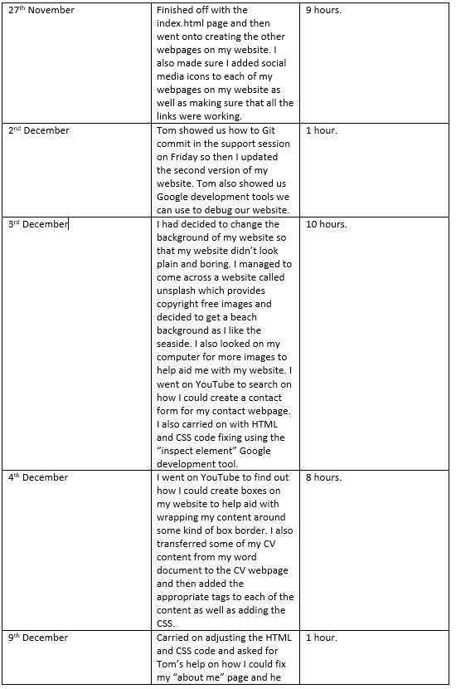](https://cloud.githubusercontent.com/assets/22633852/21948218/99d8e04a-d9e1-11e6-9906-9b225229aef3.png)

[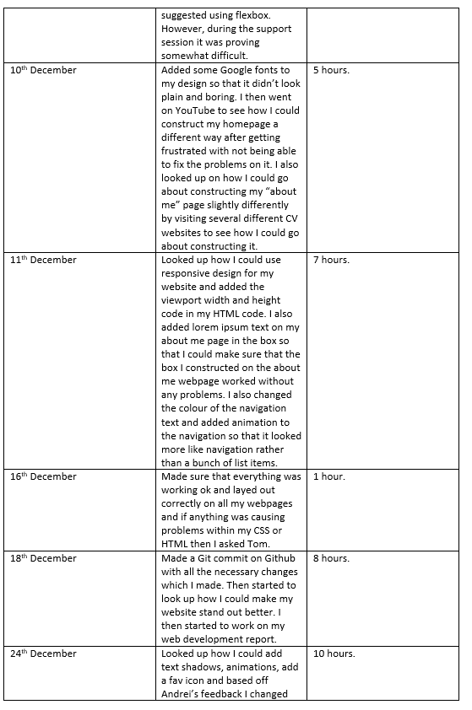](https://cloud.githubusercontent.com/assets/22633852/21948356/a1fee5e8-d9e2-11e6-848f-d11f18891659.png)

[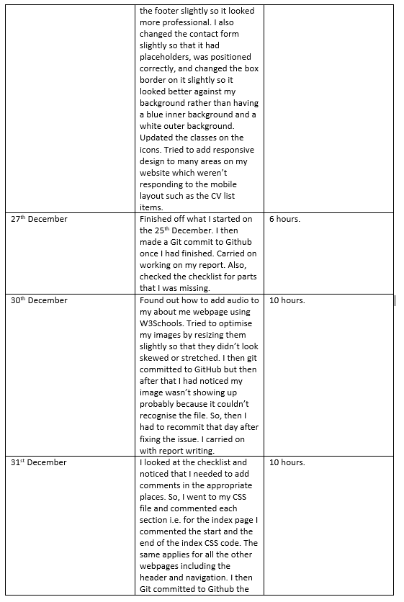](https://cloud.githubusercontent.com/assets/22633852/21948384/e3637e90-d9e2-11e6-94ad-f805ef0e875f.png)

[](https://cloud.githubusercontent.com/assets/22633852/21948384/e3637e90-d9e2-11e6-94ad-f805ef0e875f.png)

[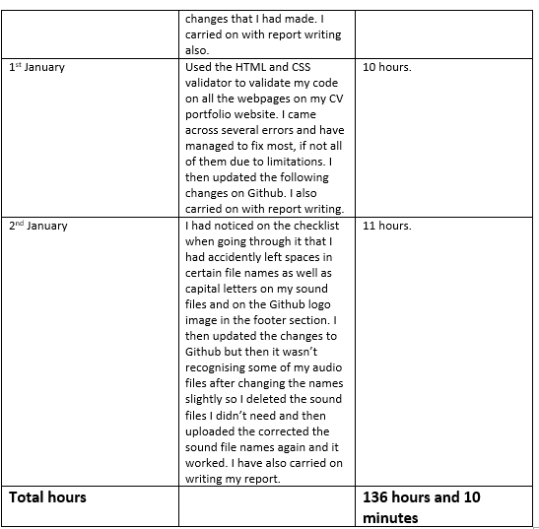](https://cloud.githubusercontent.com/assets/22633852/21948469/6b1eaaee-d9e3-11e6-8b6b-57727330d5fc.png)

**Who you collaborated with?**

* **Marius Andrei Bertescu**
* **Aakanksha Patil**
* **Amna Hira Mahmood**
* **Tom Rose**
* **Liz Coulter-Smith**

**References**

<https://css-tricks.com/snippets/html/responsive-meta-tag/>

<http://www.hyperlinkcode.com/html-image-hyperlink.php>

<http://www.dynamicdrive.com/style/csslibrary/item/depressible_circle_buttons/>

<https://socialmediawidgets.wordpress.com/>

<https://github.com/logos>

<http://www.w3schools.com/html/tryit.asp?filename=tryhtml5_audio_all>

<https://www.youtube.com/watch?v=0i7Xb22zzQM>

<https://css-tricks.com/snippets/css/a-guide-to-flexbox/>

<https://codepen.io/lizcoultersmith/pen/dOqYWK>

<http://codepen.io/UoN-ThomasRose/pen/NbYrGj>

<https://www.youtube.com/watch?v=DB14R0gt8Y8>

<https://csstricks.com/almanac/properties/t/transition/>

<http://stackoverflow.com/questions/24647139/thick-underline-when-hover>

<http://www.dynamicdrive.com/style/csslibrary/item/css_animated_underline_menu/>

<http://www.w3schools.com/tags/ref_pxtoemconversion.asp>

<http://www.w3schools.com/cssref/tryit.asp?filename=trycss3_box-shadow>

<https://codepen.io/afinedayproductions/pen/EzvLp/>

<https://www.youtube.com/watch?v=0i7Xb22zzQM>

<https://css-tricks.com/snippets/css/a-guide-to-flexbox/>

<http://stackoverflow.com/questions/5347451/centering-ul-keeping-lis-aligned>

<http://www.w3schools.com/cssref/tryit.asp?filename=trycss3_text-shadow_white>

<https://css-tricks.com/adding-stroke-to-web-text/>

<http://stackoverflow.com/questions/1040554/how-to-put-a-div-in-center-of-browser-using-css>

<https://css-tricks.com/almanac/properties/f/float/>

<https://codepen.io/afinedayproductions/pen/EzvLp/>

<https://www.youtube.com/watch?v=jJuHQNULXGs>

<http://www.w3schools.com/cssref/pr_text_text-align.asp>

<http://www.w3schools.com/css/tryit.asp?filename=trycss_border-style>

<http://www.dynamicdrive.com/style/csslibrary/item/depressible_circle_buttons/>

<https://www.abeautifulsite.net/how-to-make-rounded-images-with-css>

<https://codepen.io/cbracco/pen/zekgx>

<http://www.color-blindness.com/coblis-color-blindness-simulator/>

<http://stackoverflow.com/questions/26995179/the-for-attribute-of-the-label-element-must-refer-to-a-form-control-error>

<https://www.sitepoint.com/community/t/css-validation-unknown-vendor-extensions/125616>

<http://960.gs/>

<https://github.com/ashleighf1996/csy1018-assign1>